Nordic Center of Excellence eSTICC:
eScience Tools for Investigating Climate Change in Northern High Latitudes
Third yearly meeting and general assembly
Stockholm
Wed 5th to Fri 7th October 2016

Draft program

Venue: Stockholm University, Geoscience building, Högbomsalen (in the U building in the map below)

Dinner: Restaurant Aifur, Gamla Stan on Thursday 6.10. 19:00-21:30

Registration and information on potential dietary restrictions: to Matthias Brakebusch (matthias.brakebusch@aces.su.se) with cc: to eSTICC secretariat (esticc@nilu.no) by September 28st.

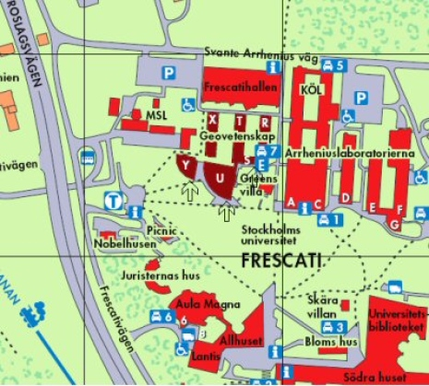

Wednesday 5.10.2016

12:00-13:00 Lunch and registration

13:00-14:00 WP 1 progress session
Chairs: Ilona Riipinen and Michael Schulz

- Michael Schulz: Progress in ESM evaluation within eSTICC (20 min)
- Ilona Riipinen (on behalf of Peter Tunved): Update on the eSTICC data portal development (20 min)
- Discussion on time and contents of a workshop focusing on Nordic climate related databases (20 min)

14:00-15:00 WP 2 progress session
Chair: Rona Thompson and Aki Tsuruta

- Rona Thompson: Estimates of CH4 fluxes in the high northern latitudes using FLEXINVERT (25 min)
- Aki Tsuruta: Methane budget estimates for northern high latitudes using CTE-CH4 and comparison with FLEXINVERT (35 min)

15:00-15:30 Coffee and fruit

15:30-16:30 WP 5 progress session
Chairs: Helmut Neukirchen, Shuting Yang and Thomas Zwinger

- Helmut Neukirchen, Shuting Yang, and Thomas Zwinger: WP5 High-Performance Computing Overview (12 min)
- Dorothée Vallot: Coupled glacier sliding and calving (12 min)
- Shahbaz Memon: Coupling glacier sliding and calving using a workflow tool (12 min)
- Thomas Zwinger: Optimization and porting environmental science codes (12 min)
- Shuting Yang: Porting and optimizing the EC-Earth on DMI/IMO's HPC (12 min)

Dinner on your own

Thursday 6.10.2016

09:00 Coffee and fruit

9:00-11:00 WP 3-4 progress session
Chairs: Hannele Korhonen and Alf Grini

- Hannele Korhonen: New MPI-ESM developments: SOA description and statistical representation of aerosol processes (25 min)
- Alf Grini: SOA / nucleation tests done with NorESM (25 min)
- Norbert Birk: Carbon cycling in Svalbard and Greenland (25 min)
- Thomas Toniazzo: Aquaplanet experiments, IFS + NorESM2 (25 min)
- Marianne Madsen: Climate-Greenland Ice Sheet interactions as simulated by EC-Earth coupled to the PISM ice sheet model (25 min)

11:00-12:00 WP 6 progress session
Chairs: Antti Lauri and Ilona Riipinen

- Michael Schulz: Applied methodologies for improved exchange between atmospheric e-Science Infrastructures at high latitudes (5 min)
- Gunilla Svensson (TBC): Introduction to climate modeling I and II (5 min)
- Michael Boy: First steps in atmospheric modelling (5 min)
- Antti Lauri: Climate Whirl at High Latitudes (5 min)
- Thomas Zwinger: eSTICC-related courses at CSC (5 min)
- TBC (on behalf of Tuula Aalto): Summer school on challenges in measurements of greenhouse gases and their interpretation (5 min)
- TBC (on behalf of Heikki Järvinen): data compression and updates about using OpenIFS on graduate courses (15 min)
- Discussion on the needs of the eSTICC student and post-doc community and future education activities (15 min)

12:00-13:00 Lunch

13:00-15:00 Session on the results from the eSTICC mobility grants
Chairs: Andreas Stohl and Michael Boy

- Juan Acosta Navarro: Interactions between land-use change and climate in the NorESM model (25 min)
- Risto Makkonen (on behalf of Roland Schrödner): Bioaerosols in EC-Earth (25 min)
- Ilona Riipinen (on behalf of Narges Rastak): Importance of organic particle hygrosopicity for capturing its climate effects in NorESM (25 min)
- Andreas Stohl (on behalf of Christine Groot Zwaaftink): Improving dust mobilization scheme of FLEXPART for Icelandic source regions (25 min)
- Michael Boy (on behalf of Emilie Örström): Development and evaluation of a new ELVOC chemistry gas phase scheme (25 min)

15:00-15:30 Coffee and fruit

15:30-17:00 Session for external visitors / potential collaborators and greetings from the SAB
Chairs:Risto Makkonen and Shuting Yang

- Nina Kirchner: Overview of the Bolin Centre activities (10 min)
- Anders Moberg: Bolin Centre database activities (10 min)
- Rodrigo Caballero: Climate modeling coordination within the Bolin Centre and Swedish eScience Research Centre SERC (10 + 15 min)
- Hamish Struthers: NSC advanced user support activities (15 min)
- Hannele Korhonen: NordicESM network (10 min)
- Greetings from the SAB (20 min)

19:00-21:30 Dinner at restaurant Aifur in Stockholm old town (Gamla Stan)

Friday 7.10.2016

09:00-09:30 Coffee and fruit

09:30-12:00 Discussion of future activities and mid-term report
Chairs and moderators: Ignacio Pisso and Andreas Stohl

